# **How to use Tenx**

Welcome to tenx, the platform designed specifically for trainees enrolled in 10 Academy's online education. This guide aims to assist you in navigating through the essential steps to effectively utilize the features and functionalities of tenx.

## Logging In

Begin your journey by visiting the login page [here](https://kaimtenx.10academy.org/). Enter the **email you used to register** for 10 Academy as both the username and password into the provided fields.

After, make sure to hit ‘forgot password’ to reset your login credentials, reset link will be sent to your email.

If you do not have login info, contact cohort manager [Makida Shimeles](mailto:makida@10academy.org).

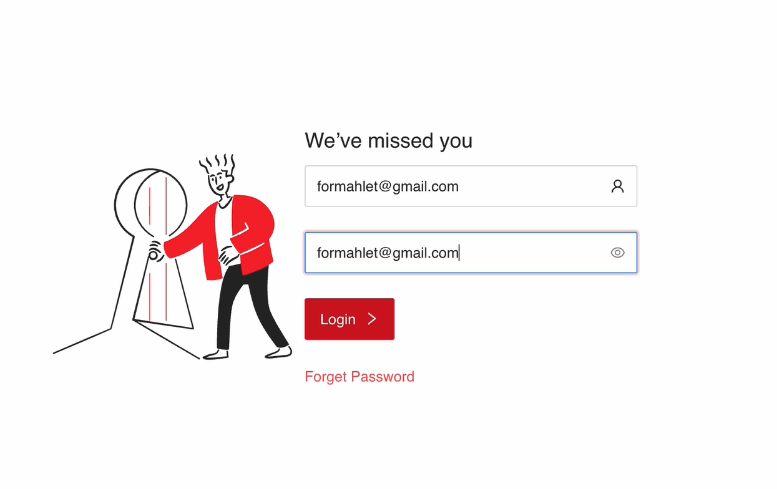

### Resetting Your Password

Upon login, expect a notification stating that an email has been sent to facilitate a password change. Head to your email inbox and open the email you received from 10 Academy.

Inside the email, you will find a link designed for resetting your password. Click on this link to proceed.

You'll be directed to a new page where you can input your desired new password. Enter it and confirm by typing it again.

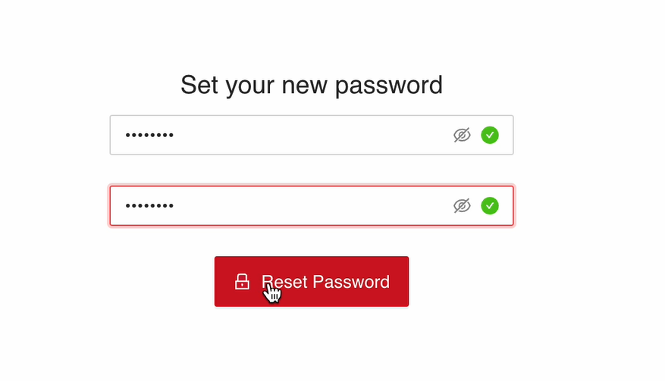

## Accessing Your Dashboard

Re-login using your newly updated password [here.](https://kaimtenx.10academy.org/) Once logged in, your personalized dashboard awaits you.

Explore the left sidebar of your dashboard to find various links leading to different functionalities. Discover sections such as challenges, performance leaderboard, assignments, and more.

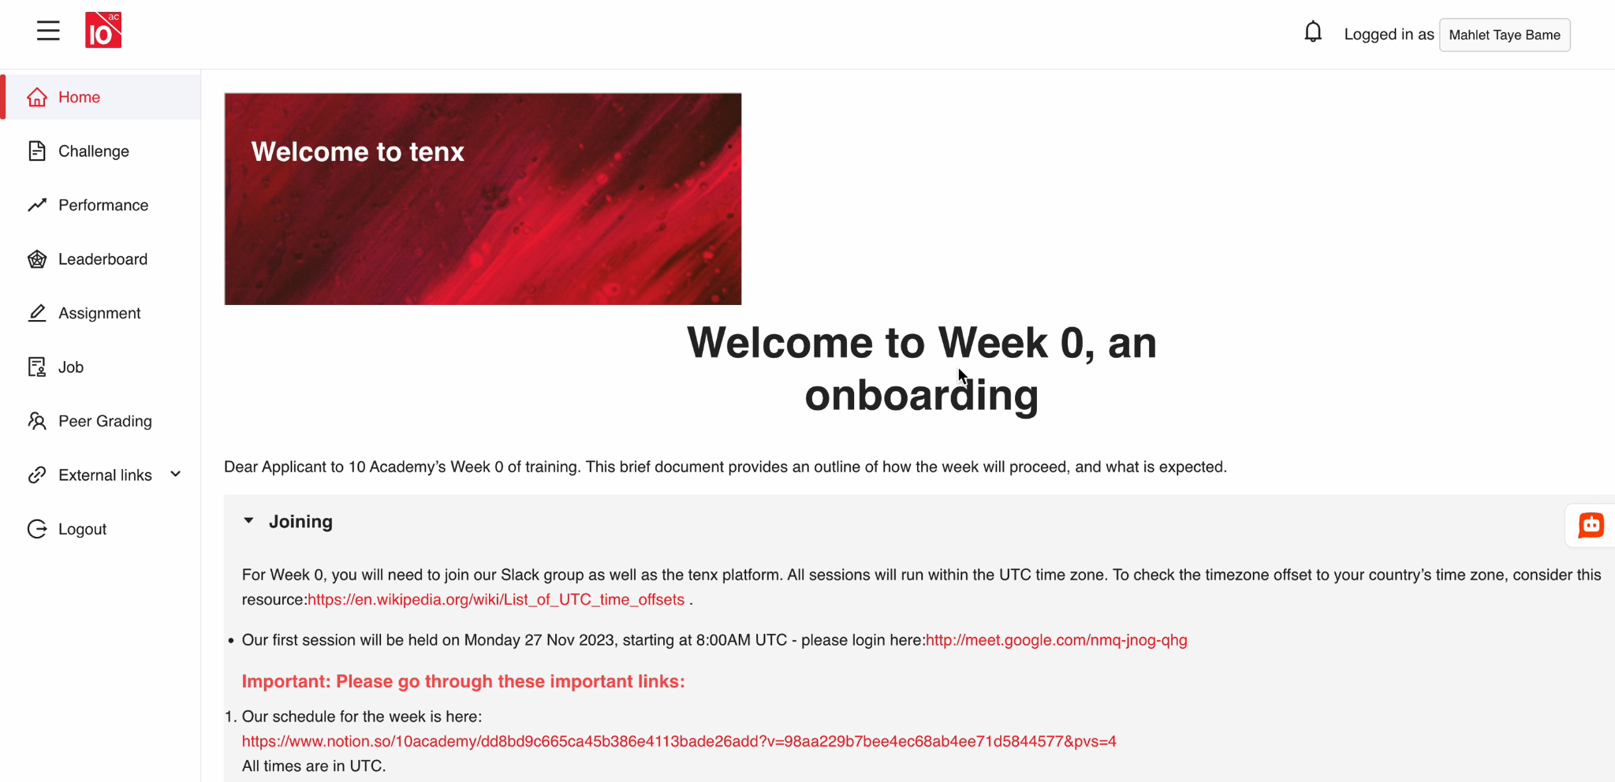

## Submitting Assignments

To submit your assignments, navigate to the 'Assignments' section through the sidebar. Choose the specific assignment you wish to complete.

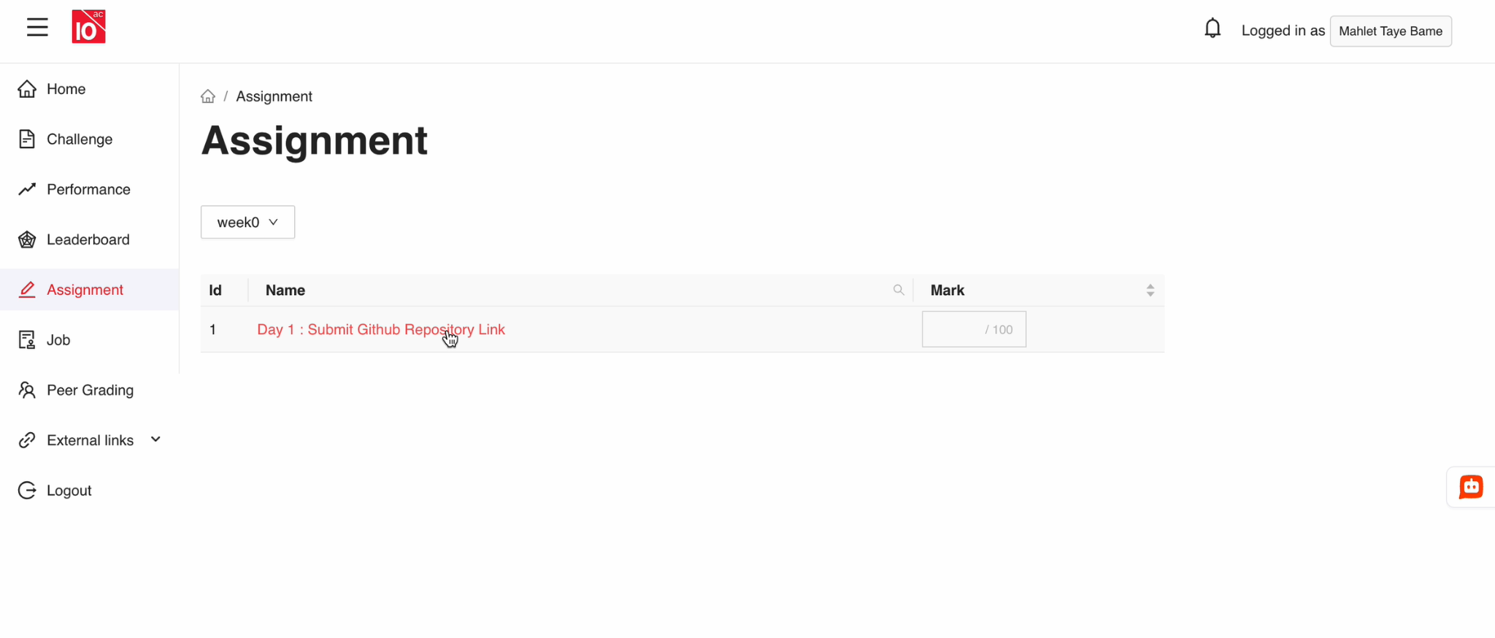

Follow the prompts and instructions provided within the assignment section to submit your work as requested.